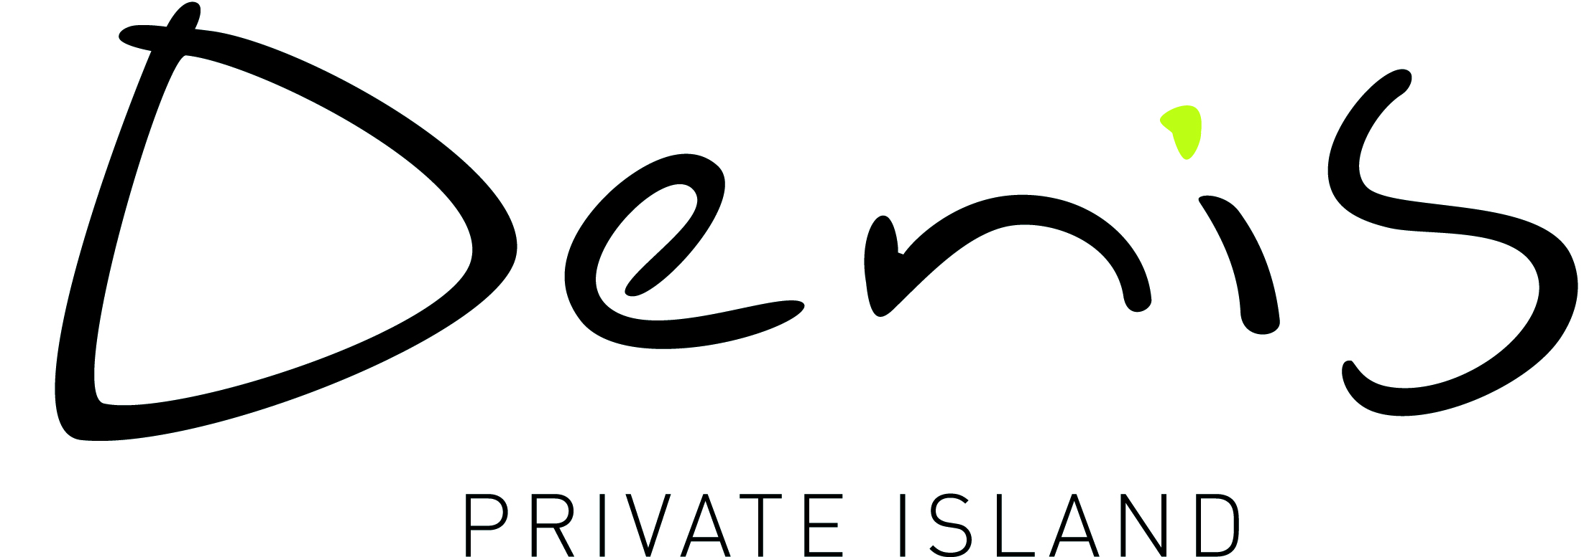

**Press Trip Guidelines**

Thank you for taking an interest in Denis Private Island. We are always glad to assist travel writers and journalists in promoting this special place. Our goal is to share the experiences and beauty of such a rare place and to in turn welcome more guests by adequately covering articles, books, videos or other broadcasts.

As we receive a considerable number of requests from journalists seeking media privileges, we have created this request form so we can most effectively meet your editorial, photographic and/or other broadcasting needs.

**Please note:**

* We request a minimum of 4 business weeks notice for a press request once we have received all the required information requested. This allows us ample time to seek available and appropriate lodging and other arrangements to enhance your visit.
* Request of transfers
* Please email us a letter of assignment on letterhead from the media outlet you are representing.
* Freelance journalists should forward recent examples of travel or trade related feature coverage to accompany their application request form.
* Any changes relating to dates or itineraries must be advised to the relevant person at Denis Private Island immediately.
* To remain on our preferred media list, please forward an original copy of your published feature, print, tape, DVD or relevant links as soon as available.
* All coverage must be done within a 6 month time frame of having completed the travel itinerary.
* Please understand that our primary concern is assisting work press trips. Host locations are not always able to accommodate spouses, children and visitors that may be accompanying working press.

Thank you for your interest in Denis Private Island!

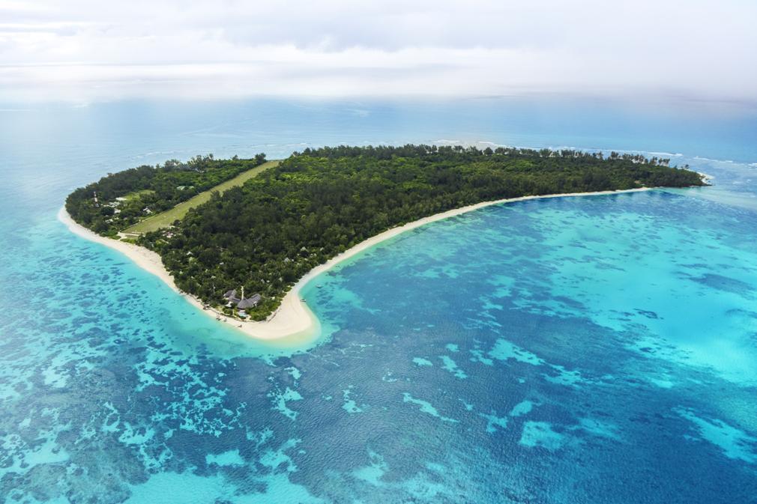



**Press Trip Request Form**

Please complete the below and return to Nstange@masonstravel.com

or to the relevant contact person at Denis Private Island.

* These fields are mandatory



**Type here!**

**Type here!**

**Type here!**

**Type here!**

**Type here!**

**Type here!**

**Type here!**

**Type here!**

**Type here!**

**Type here!**

**Type here!**

**Type here!**

**Type here!**

**Project Contact person*:**

**List names of people and their role on this trip:**

**Organization*:**

**Phone*: Email*:**

**Country of publication/broadcast*:**

**Project Information**

**Name of Project*: Preferred Travel Dates:**

**How will this project be publicized* (please tick where appropriate):**

**Online Email Distribution TV Documentary Radio Broadcast**

**Event Projection Print Article DVD Distribution Other**

**Frequency of this media:**

**Is this project part of a larger print, social media or broadcast campaign? If so, please explain.**

**When is the deadline for completion of this project:**

**Will Denis receive content for approval prior to publishing? Yes No**

**When is the expected publication date*:**

**Are there any other local partners involved on this project, if so please specify*:**

**Client Information**

**Flights to Denis Private Island are payable unless otherwise agreed to. A return Mahe/Denis/Mahe flight is at €416 pp.**

**Please read the attached flight information notice.**

*Thank you for taking the time to complete this and return to our team with all the relevant information required to assist us in the decision-making process. We shall process your request and revert to you in the next 3 business days.*

**Flights**

**On which basis is the exchange of services being done?: Complimentary Preferred Rates**

**Exchange of Services**

**Press Trip Request Form**

**Who is the target audience*:**

**What is the circulation*:**

**What is the angle of your story/activities of interest*:**

**What message would you like your audience to take away from the project*:**

**What benefit is there for Denis Private Island to participate in this project*:**

**Is Denis Private Island granted permission to use the material for their own promotional use?*: Y/N**

**Audience Information**